* **x – cos(x) = 0**
* **Bisection Method**

*Output:*

Root: 0.739078

Iterations required: 14

>Plots :

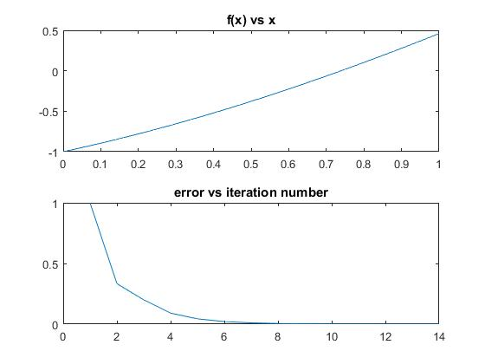

* **False Position Method**

*Output:*

Root: 0.739085

Iterations required: 5

>Plots :

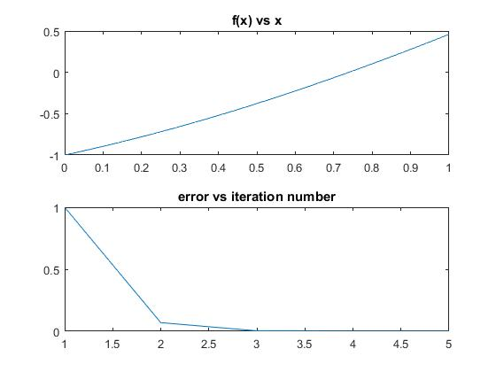

* **Fixed Point Method**

*Output:*

Root: 0.739106

Iterations required: 25

>Plots:

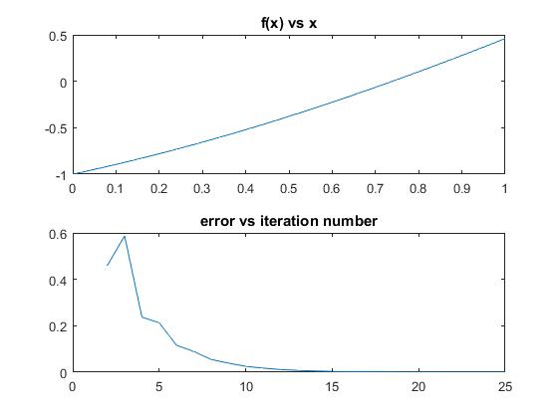

* **Newton-Raphson Method:**

*Output:*

Root: 0.739085

Iterations required: 4

>Plots:

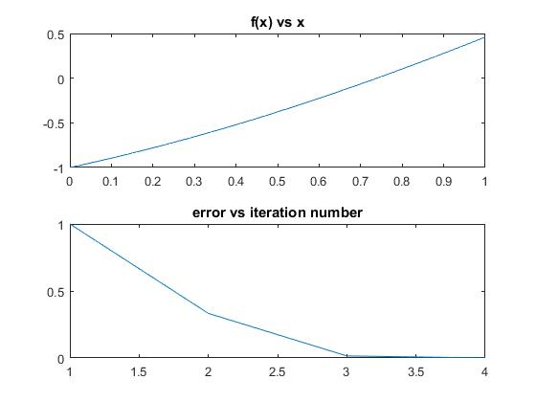

* **Secant Method**

*Output:*

Root: 0.739085

Iterations required: 4

>Plots:

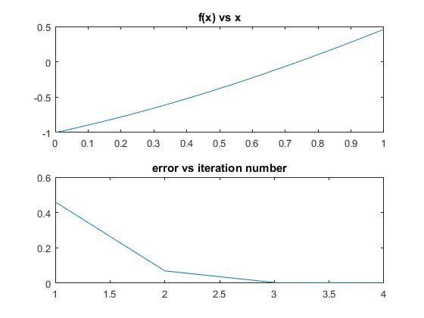

* **exp(-x) – x = 0**
* **Bisection Method:**

*Output:*

Root: 0.567139

Iterations required: 12

>Plots:

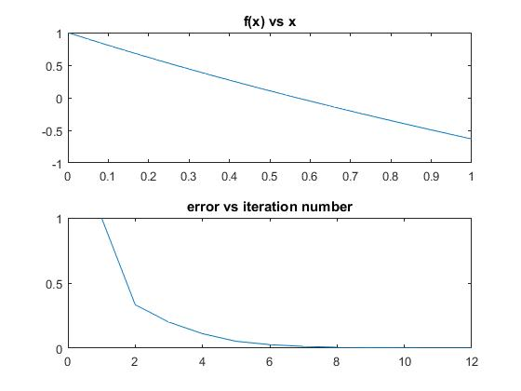

* **False Position Method:**

*Output:*

Roots: 0.567150

Iterations required: 5

>Plots

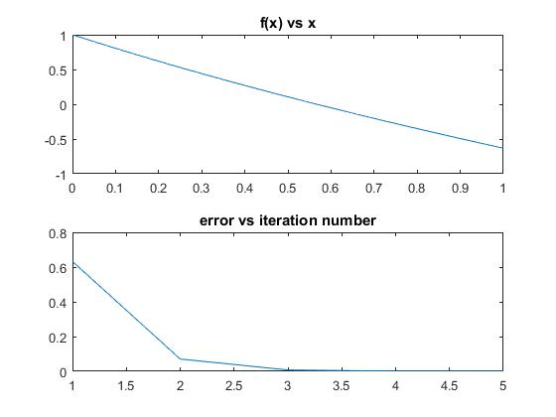

* **Fixed Point Method:**

*Output:*

Roots: 0.567068

Iterations required: 16

>Plots

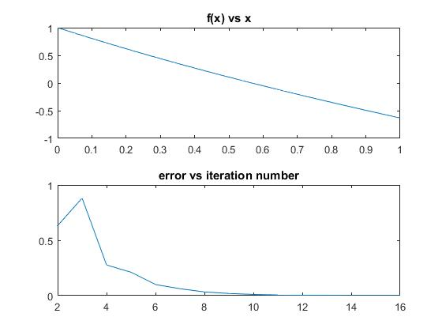

* **Newton Method:**

*Output:*

Roots: 0.567143

Iterations required: 4

>Plots

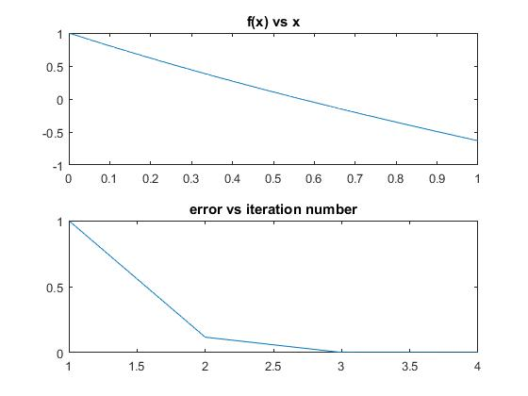

* **Secant Method:**

*Output:*

Roots: 0.567143

Iterations required: 4

>Plots

